**CMSC203**

**Assignment #1**

Wi-Fi Diagnosis

We all need internet connectivity in this age of lockdowns. What steps should you go through when you do not have connectivity?

**Assignment Description**

Build an application that will step through some possible problems to restore internet connectivity. Assume that your computer uses wi-fi to connect to a router which connects to an Internet Service Provider (ISP) which connects to the Internet.

**Concepts Covered**

* Java fundamentals, including decision structures
* Following a flow-chart
* Command-line processing

**Assignment Details**

* Write a program based on the following flow-chart.
* **Note:**
  + Your application should start with a header exactly with the same wordings as follows:

*If you have a problem with internet connectivity this WiFi Diagnosis might work.*

* + Make sure to use the exact wordings as shown in the flowchart.
* Notice that few words/sentences in the flowchart are repetitive(constant); declare constant variables for those words/sentences; for example, the decision question, Yes, No
* If the user enters an invalid response, notify the user by displaying “Invalid answer; try again” and exit the program.
* You should make sure to handle the Yes/No responses regardless of the case (uppercase/lowercase Yes/No).
* Prompt the user at each step, and if they respond that the step they took fixed the problem, exit the program. A close up of a map

  Description automatically generated

You are required to run the application from the command line and from an IDE (like Eclipse). Take screenshots of two runs of your program with different inputs, one from the command line and one from your IDE.

**Examples/Sample Runs**

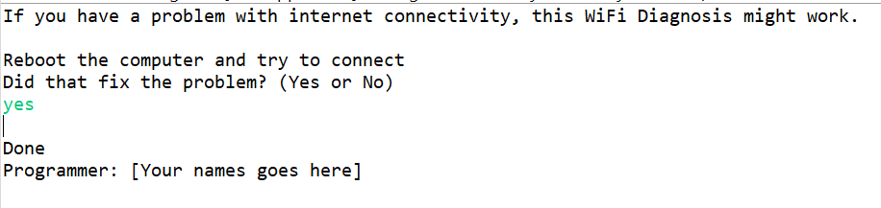

Application Header

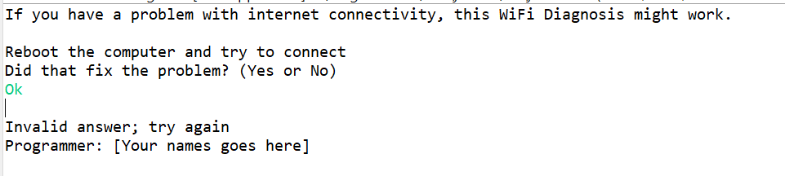

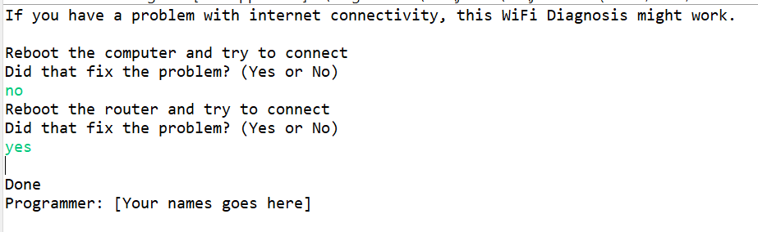

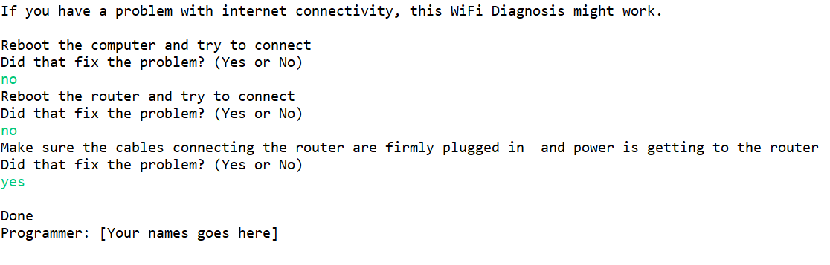

**Deliverables**

**Deliverables / Submissions and Deliverable format:**

* The Java application must compile and run correctly, otherwise project grade will be zero.
* The detailed grading rubric is provided in the assignment rubric excel file.
* Your source code should contain proper indentation and documentation.
* Documentation within a source code should include
  + additional Comments to clarify a code, if needed
  + class description comments at the top of each program containing the course name, the project number, your name, the date, and platform/compiler that you used to develop the project, for example:

/*

 * Class: CMSC203

 * Instructor:

 * Description: (Give a brief description for each Class)

 * Due: MM/DD/YYYY

* Platform/compiler:

 * I pledge that I have completed the programming

* assignment independently. I have not copied the code

* from a student or any source. I have not given my code

* to any student.

   Print your Name here: __________

*/

The deliverables will be packaged as follows. Two compressed files in the following formats:

* **FirstInitialLastName_Assignment1_Complete.zip**, a compressed file in the zip format, with the following:
  + src folder:
    - * + includes only WifiDiagnosis.java
  + Word document that includes (use provided template):
    - 1. Screenshots:
         1. One screenshot of the application running from the command prompt line.
         2. One screenshot of the application running in your IDE.
         3. Screen shot of Java file (WifiDiagnosis.java) in your GitHub repository
      2. Lessons Learned: Provide answers to the questions listed below:
         1. Write about your Learning Experience, highlighting your lessons learned and learning experience from working on this project.
         2. What have you learned?
         3. What did you struggle with?
    - **FirstInitialLastName_Assignment1_JavaFiles.zip**, a compressed file containing one or more Java files **(This folder SHOULD NOT contain any folders and it should contain Java source file only):**
      * + WifiDiagnosis.java